CCNA – WAN Architectures
Leased Lines • Ethernet WAN • MPLS • Internet Connections • VPNs (IPsec, GRE, TLS)
Exam-focused revision notes with original slide images
How to use these notes
Each topic = Concept → Key Points → Example → Original slide image. Words in red bold are exam keywords.
These slides contain no Cisco commands (this is a theory topic). Comparison tables and Quick Revision are at the end.

Topic 1: WAN Architectures – The Basics

1. Concept
A WAN (Wide Area Network) is a network that spreads over a large geographic area. Its job is to connect geographically separate LANs (e.g., head office in Chennai ↔ branch in Delhi ↔ data center in Mumbai).

Key Points
- The Internet can technically be called a WAN, but in exams "WAN" usually means an enterprise's private connections between offices, data centers and other sites.
- Over public/shared networks (like the Internet), VPNs (Virtual Private Networks) create private WAN connections.
- Many WAN technologies exist. Availability depends on location.
- A technology that is legacy (old) in one country may still be widely used in another.

Example
PC (Branch) → Switch → Router → WAN link → Router → Switch → Server (Data Center). The WAN link is the part between the two routers.

📷 Image / Diagram
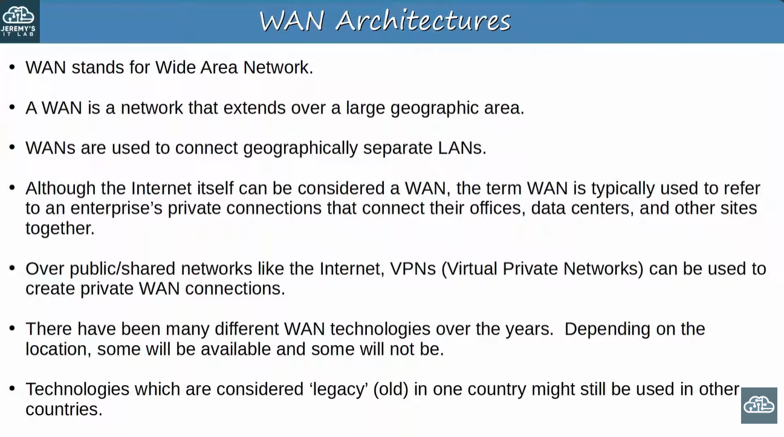
WAN Architectures – definition and key facts

Topic 2: WAN over Dedicated Connection (Leased Line)

1. Concept
A leased line is a dedicated physical link rented from a service provider (SP). The enterprise connects its sites with point-to-point leased lines. Only your traffic uses that link.

Key Points
- Common design = hub-and-spoke: the Data Center is the HUB, each office is a SPOKE.
- Logically: one leased line from hub to each spoke (Office A, B, C).
- Physically: every leased line goes through the service provider's network, and each site gets a serial connection to the SP.
- Because the link is dedicated, traffic is naturally separated and secure.

Example
Office A PC → Switch → Router (A) → Leased line → Data Center Router → Switch → Server. Office A to Office B traffic normally goes via the hub (A → Hub → B).

📷 Image / Diagram
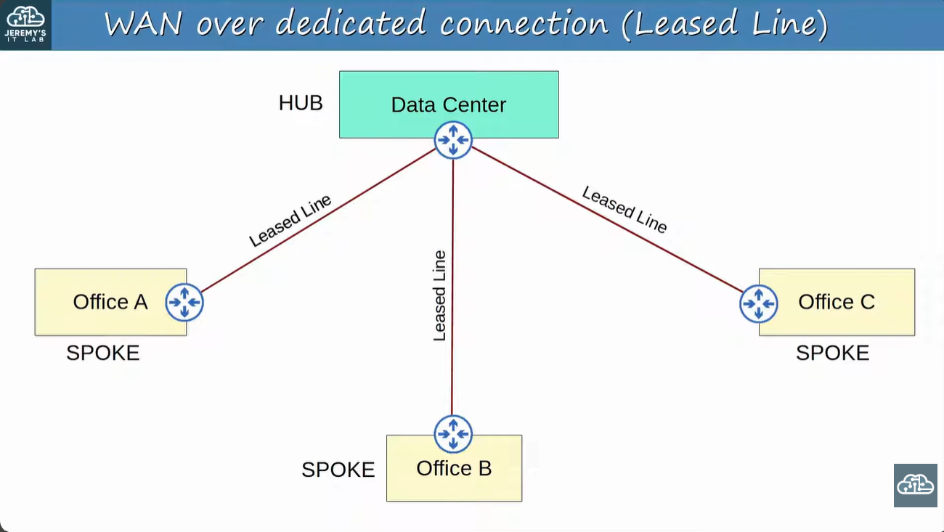
Logical view: hub-and-spoke leased lines

📷 Image / Diagram
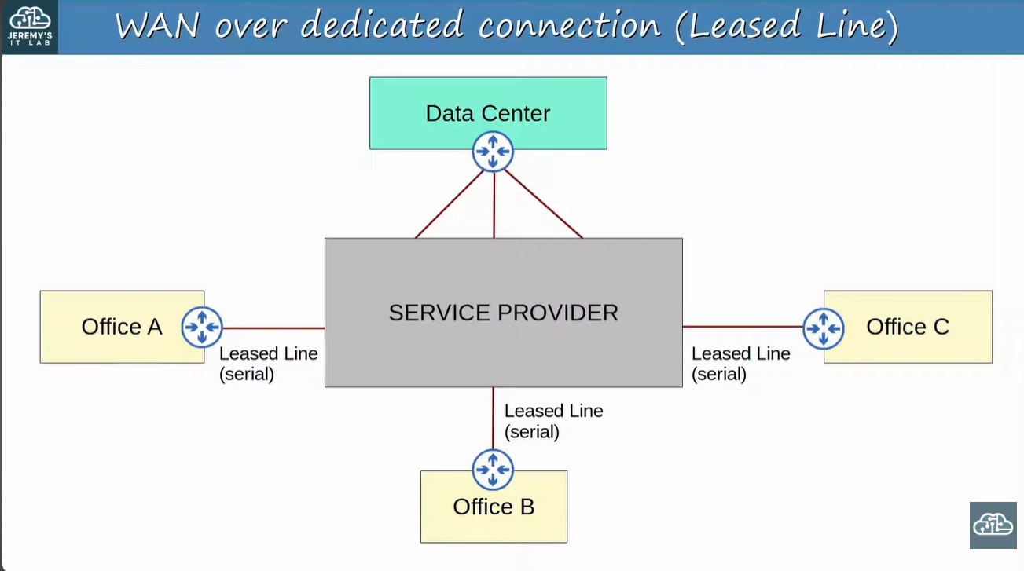
Physical view: leased lines (serial) through the service provider

Topic 3: Leased Line Details & Standards (T-carrier / E-carrier)

1. Concept
Leased lines use serial connections with PPP or HDLC encapsulation. Different regions use different speed standards: T-carrier (North America/Japan) and E-carrier (Europe/CEPT). The base unit is a 64 kbit/s channel (DS0).

Key Points
- T1 = 1.544 Mbit/s (24 channels), E1 = 2.048 Mbit/s (32 channels).
- T3 = 44.736 Mbit/s, E3 = 34.368 Mbit/s.
- Leased lines have higher cost, long installation time and slower speeds → Ethernet WAN is becoming more popular.
Level | North American (T) | European (E)
First | T1 – 1.544 Mbit/s (24 ch.) | E1 – 2.048 Mbit/s (32 ch.)
Second | T2 – 6.312 Mbit/s (96 ch.) | E2 – 8.448 Mbit/s (128 ch.)
Third | T3 – 44.736 Mbit/s (672 ch.) | E3 – 34.368 Mbit/s (512 ch.)

Exam Tip
Remember the circled ones: T1, T2, T3 and E1, E2, E3. T1 = 1.544 Mbps, E1 = 2.048 Mbps is the classic question.

📷 Image / Diagram
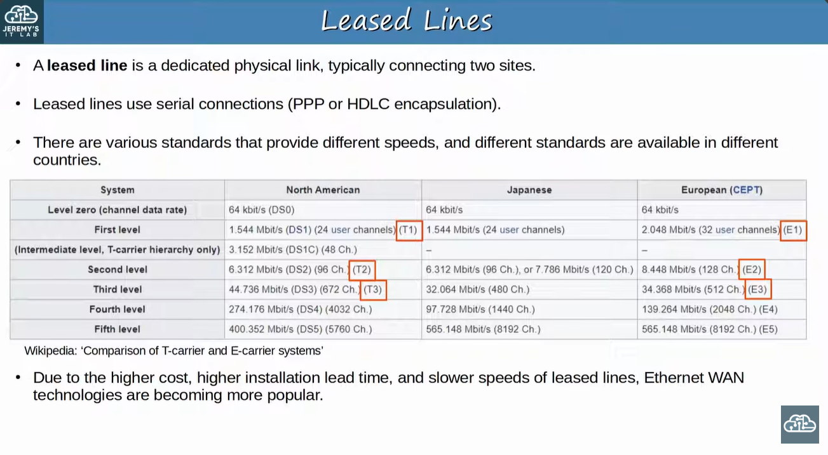
Leased lines – serial, PPP/HDLC and speed standards

Topic 4: WAN Connection via Ethernet (Fiber)

1. Concept
Instead of serial leased lines, each site connects to the service provider using Ethernet over fiber. The topology looks the same (sites connect to the SP), but the link technology is Ethernet.

Key Points
- Higher speeds and lower cost than serial leased lines.
- Same Ethernet used in LANs → easier for engineers and equipment.
- Commonly called Ethernet WAN (the provider may also sell it as Metro Ethernet).

Example
Office A Router —(Ethernet fiber)→ SP network —(Ethernet fiber)→ Data Center Router.

📷 Image / Diagram
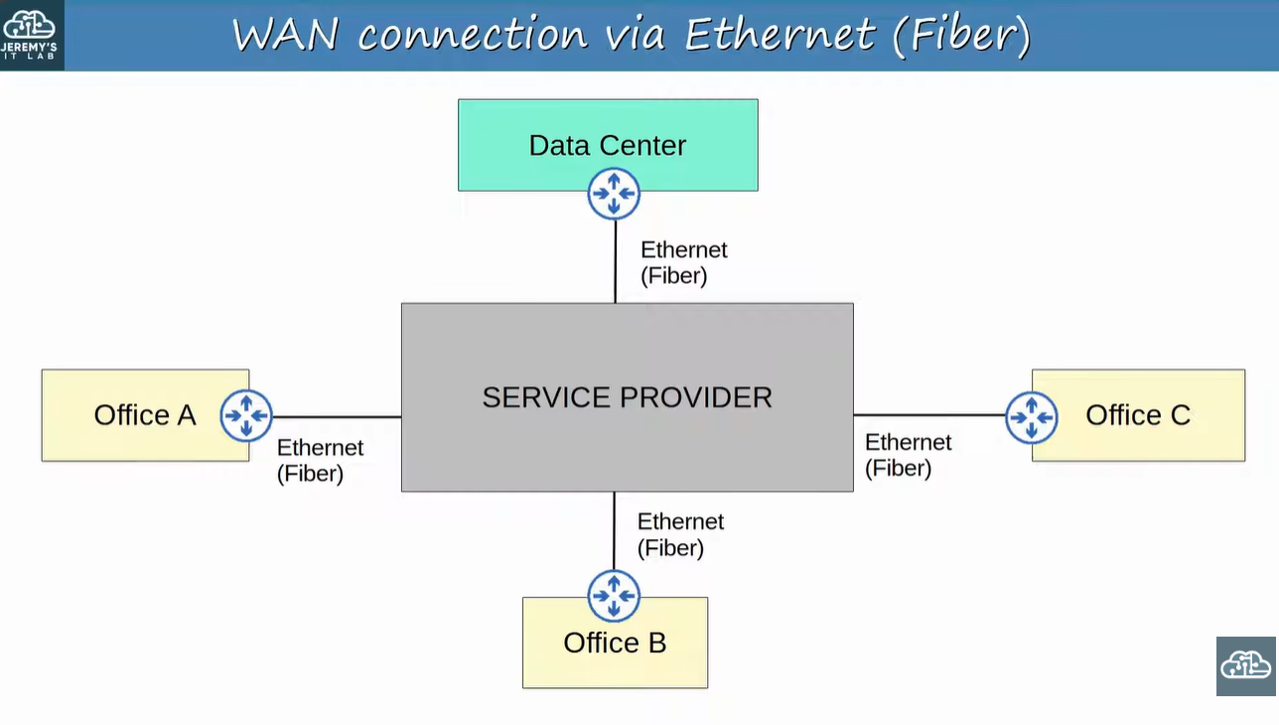
WAN connection via Ethernet (Fiber)

Topic 5: WAN over Shared Infrastructure (Internet VPN)

1. Concept
Each site connects to the Internet (black line = physical connection to the Internet). On top of that, IPsec VPN tunnels are built between the sites, creating private WAN connections over a public network.

Key Points
- Internet = shared infrastructure, so VPN tunnels are needed for security.
- Physical link goes to the Internet; the tunnel is logical.
- Cheap and quick to set up compared with leased lines.

📷 Image / Diagram
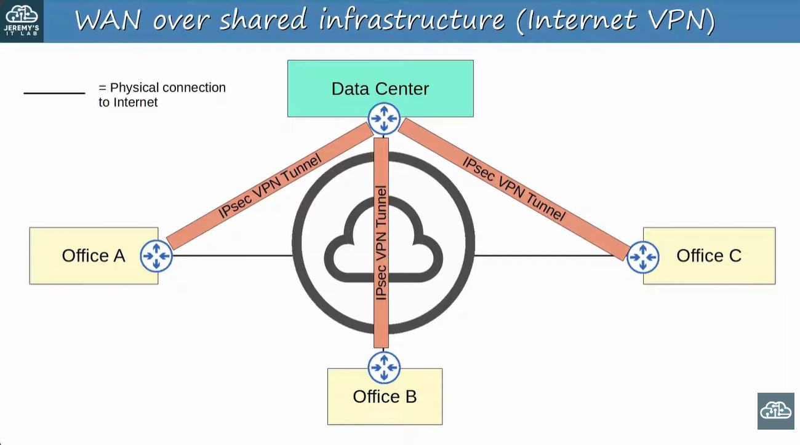
WAN over Internet using IPsec VPN tunnels

Topic 6: MPLS – Concept and Terms

1. Concept
MPLS = Multi Protocol Label Switching. It is a service provider WAN technology. The provider's MPLS network is shared infrastructure (many customers), but labels allow separate VPNs for each customer.

Key Points
- CE router = Customer Edge (your router).
- PE router = Provider Edge (SP router that connects to the customer).
- P router = Provider core router (inside the SP network).
- When a PE receives a frame from a CE, it adds a label.
- Labels are used for forwarding decisions inside the SP network – NOT the destination IP.

Example
Office A PC → Switch → CE → PE → P → P → PE → CE → Switch → Office B server. The SP core forwards by label, not by IP.

📷 Image / Diagram
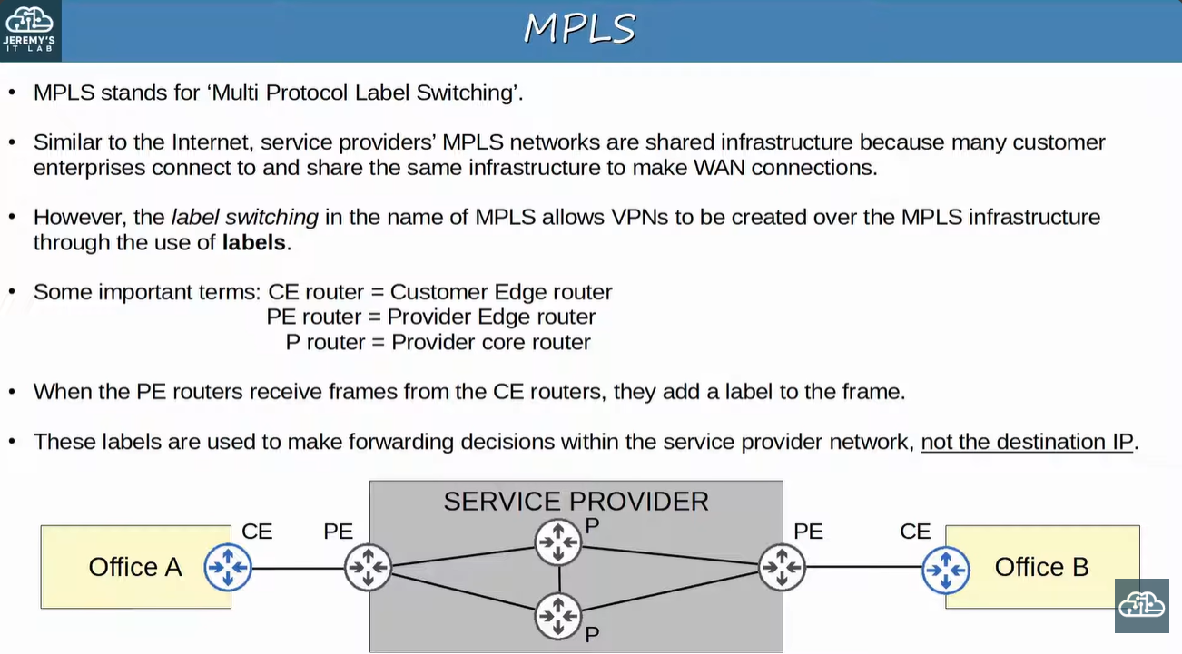
MPLS terms: CE, PE, P and labels

Topic 7: Layer 3 MPLS VPN

1. Concept
In a Layer 3 MPLS VPN, the CE and PE routers form routing peerings (e.g., OSPF) to exchange routes. The CE routers themselves do not run MPLS – only PE/P routers do.

Key Points
- Office A's CE peers with its PE; Office B's CE peers with the other PE.
- Through these peerings, A learns B's routes and B learns A's routes.
- The CE only sees the PE as its routing neighbor – not the other office's CE.

📷 Image / Diagram
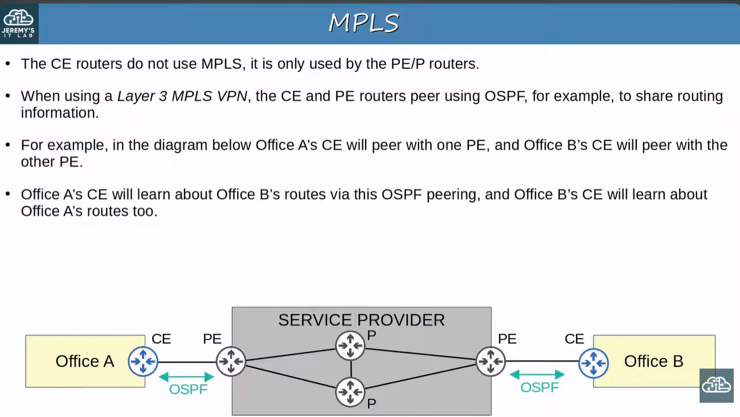
Layer 3 MPLS VPN – CE/PE OSPF peering

Topic 8: Layer 2 MPLS VPN

1. Concept
In a Layer 2 MPLS VPN, the CE and PE routers do not form peerings. The SP network is transparent – it behaves like a big switch, as if the two CE routers are directly connected.

Key Points
- CE routers' WAN interfaces are in the same subnet.
- If a routing protocol is used, the two CE routers peer directly with each other (e.g., OSPF between Office A CE and Office B CE).

Example
Office A CE = 10.0.0.1/30 and Office B CE = 10.0.0.2/30 (same subnet). OSPF neighbors form between the two CEs, across the SP.

📷 Image / Diagram
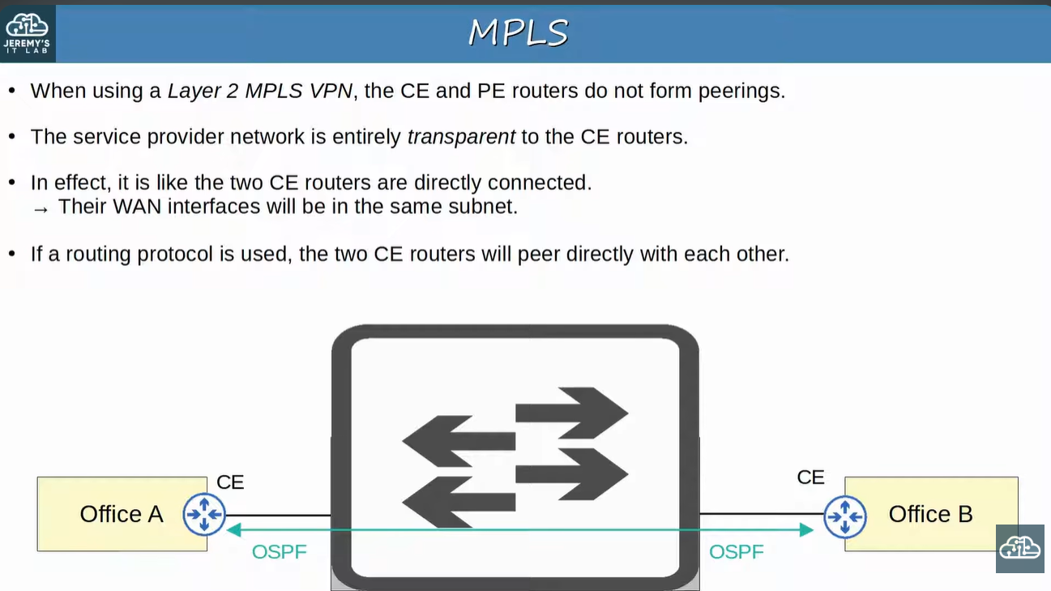
Layer 2 MPLS VPN – SP is transparent, CEs peer directly
Feature | Layer 3 MPLS VPN | Layer 2 MPLS VPN
CE–PE peering | Yes (e.g., OSPF) | No
CE peers with | The PE router | The other CE router directly
SP network | Participates in routing | Transparent (like a switch)
WAN subnet | Separate subnet per CE–PE link | Same subnet between both CEs
CE runs MPLS? | No | No

Topic 9: Access Options for MPLS WAN

1. Concept
A customer can reach the SP's MPLS network using many different technologies. The WAN service stays the same – only the access link changes.

Key Points
- Shown in the slide: Ethernet (Fiber), CATV (Cable TV), Serial, 4G/5G (wireless).
- Each office connects to a PE router of the provider.
- Offices A and B use Ethernet fiber, C uses 4G/5G, D uses CATV, E uses serial.

📷 Image / Diagram
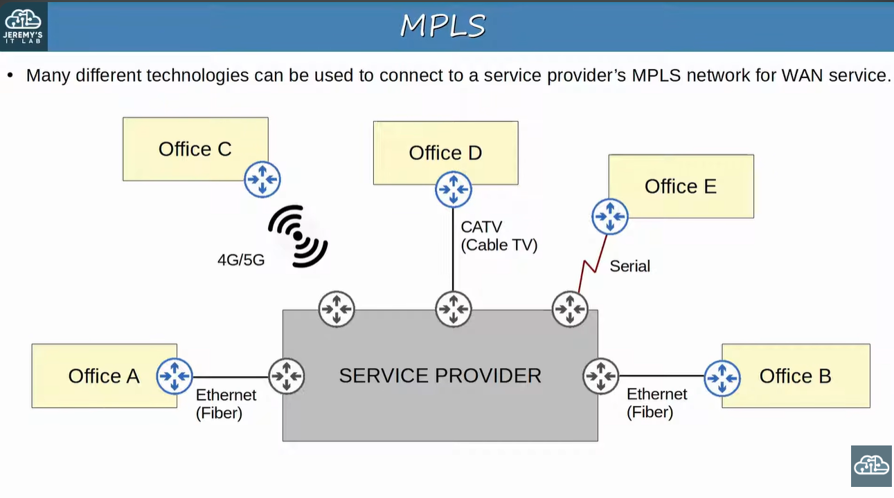
Different technologies can connect to an MPLS network

Topic 10: Internet Connections

1. Concept
An enterprise has countless ways to reach the Internet. Private WAN technologies (leased line, MPLS VPN) can connect to the SP's Internet infrastructure, and consumer technologies (CATV, DSL) can also be used by enterprises.

Key Points
- Fiber optic Ethernet is growing in popularity (high speed over long distances) for both enterprise and home users.
- Next two slides: DSL and Cable.

📷 Image / Diagram
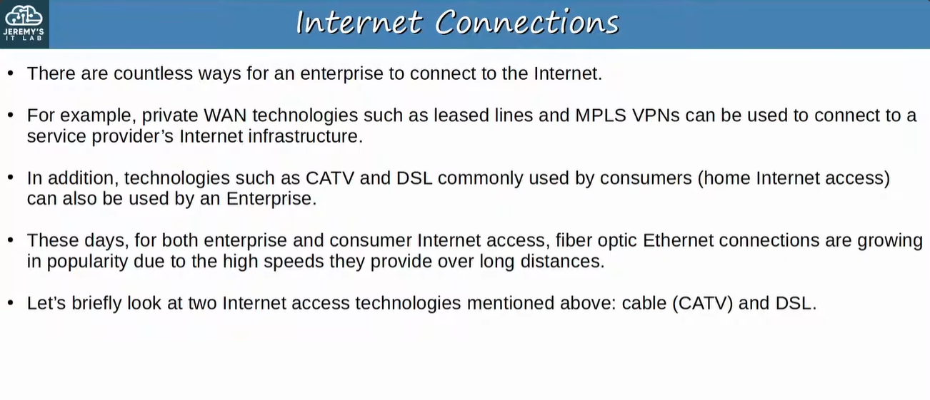
Internet connection options

Topic 11: Digital Subscriber Line (DSL)

1. Concept
DSL provides Internet over telephone lines, and can share the same phone line already installed in homes. A DSL modem (modulator-demodulator) converts data into a format suitable for phone lines.

Key Points
- Medium = phone line.
- The modem can be a separate device or built into the home router.
- Home router also includes a switch, router, firewall and Wi-Fi access point.

Example
Laptop/PC → Home Router (switch + router + firewall) → DSL Modem → Phone line → Service Provider → Internet.

📷 Image / Diagram
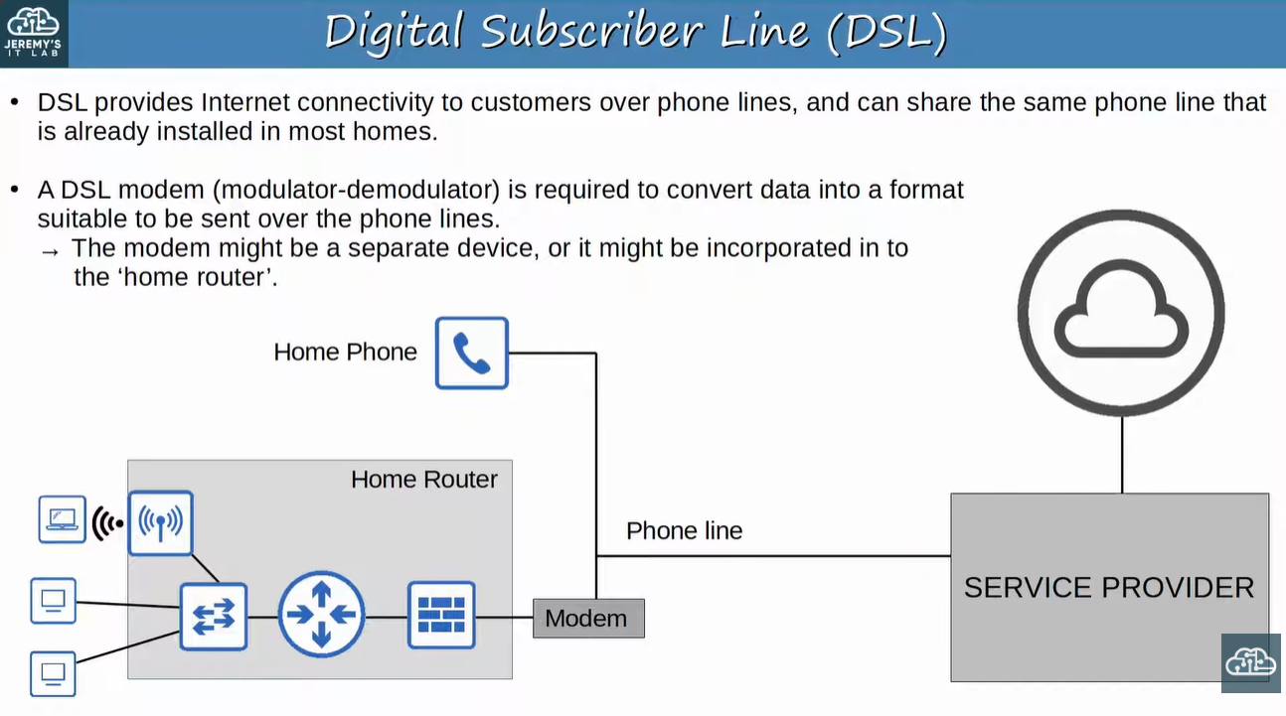
DSL – Internet over phone lines

Topic 12: Cable Internet

1. Concept
Cable Internet uses the same CATV (Cable Television) lines that deliver TV service. A cable modem converts data to a format suitable for CATV cables.

Key Points
- Medium = CATV coaxial line.
- Like DSL, the modem can be separate or built into the home router.
Feature | DSL | Cable
Medium | Phone line | CATV (cable TV) line
Device needed | DSL modem | Cable modem
Shares line with | Home phone | TV service
Modem location | Separate or inside home router | Separate or inside home router

📷 Image / Diagram
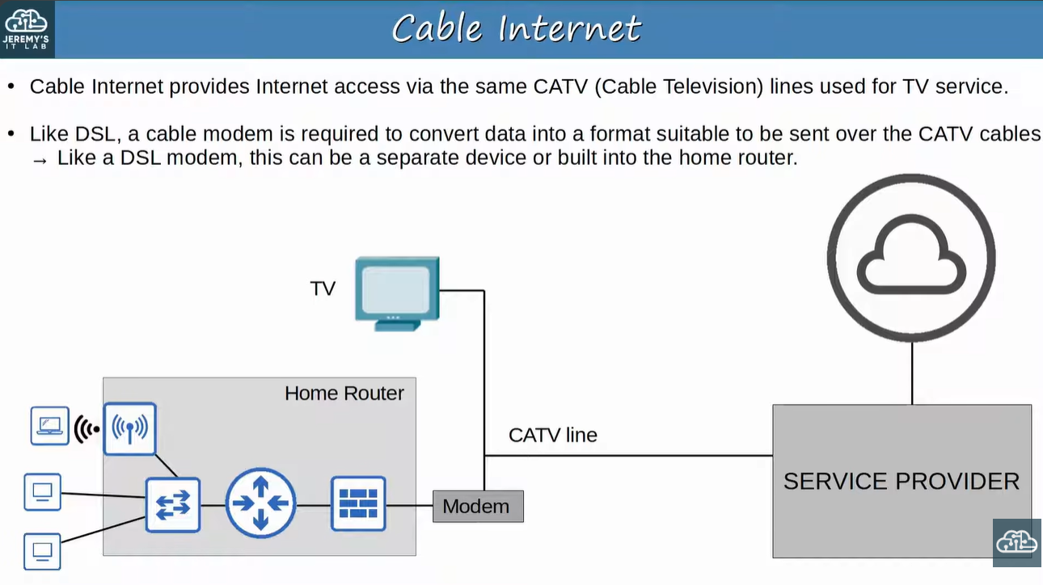
Cable Internet – Internet over CATV lines

Topic 13: Redundant Internet Connections

1. Concept
To avoid a single point of failure, enterprises add redundant Internet connections. The name depends on how many connections and how many ISPs.
Name | Connections | ISPs
Single Homed | 1 connection | 1 ISP
Dual Homed | 2 connections | 1 ISP
Multihomed | 1 connection to each ISP | 2 ISPs
Dual Multihomed | 2 connections to each ISP (4 total) | 2 ISPs

Key Points
- Dual = two connections per ISP. Multi = more than one ISP.
- Dual Multihomed = most redundant (survives link failure, router failure and even an ISP outage).
- Single Homed = cheapest but a single point of failure.
Exam Tip
"1 link, 1 ISP" = Single Homed; "2 links, 1 ISP" = Dual Homed; "1 link each to 2 ISPs" = Multihomed; "2 links each to 2 ISPs" = Dual Multihomed.

📷 Image / Diagram
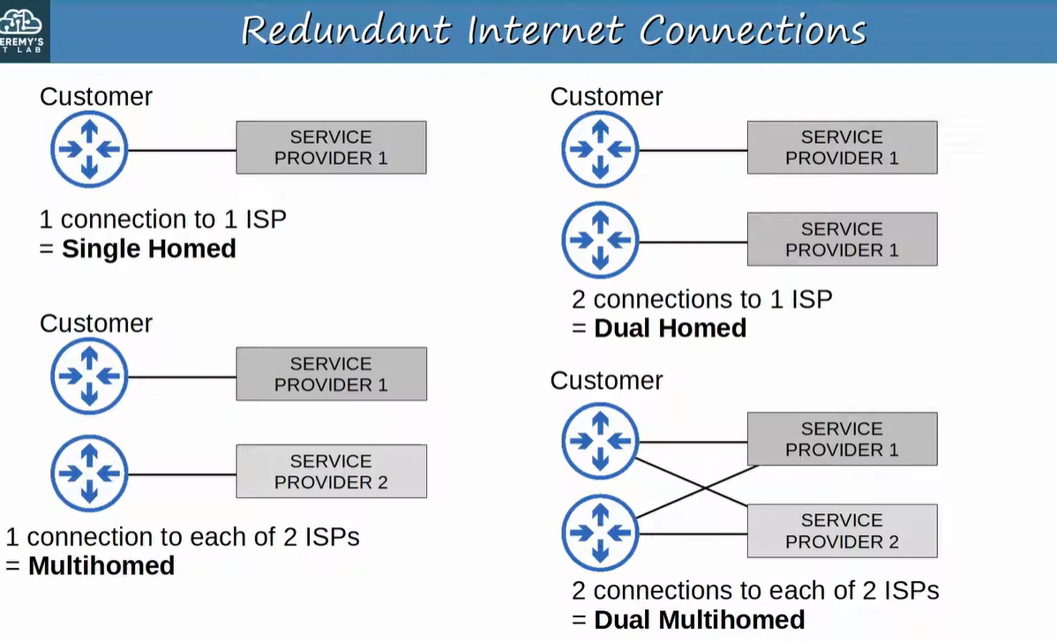
Redundant Internet connection types

Topic 14: Internet VPNs – Why We Need Them

1. Concept
Private WAN services (leased line, MPLS) are secure because traffic is separated by dedicated physical links or MPLS labels. The Internet has no built-in security by default, so VPNs are used to secure traffic across it.

Key Points
- Two kinds covered: 1) Site-to-Site VPN using IPsec and 2) Remote-Access VPN using TLS.
- Site-to-site = connects two sites. Remote-access = connects individual users/devices to the company.

📷 Image / Diagram
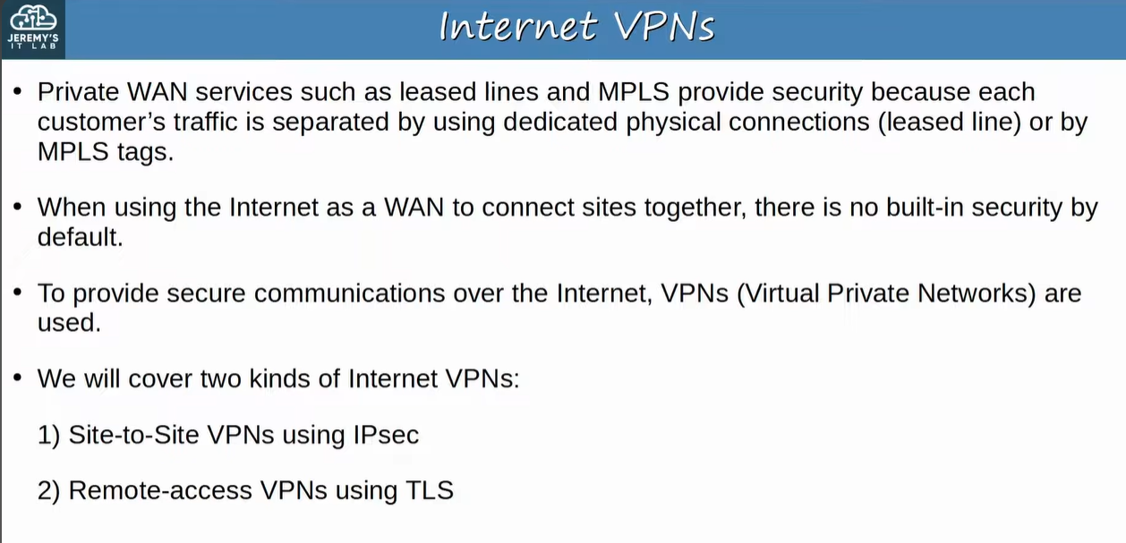
Internet VPNs – overview

Topic 15: Site-to-Site VPN (IPsec)

1. Concept
A site-to-site VPN connects two sites over the Internet using a tunnel between two devices (usually routers/firewalls). The original IP packet is encrypted and then encapsulated with a VPN header + new IP header.

Key Points
- Packet order (as in slide): New IP header | VPN header | Encrypted original packet.
- Other devices in each site send normal unencrypted data to their router – the router does the encryption.
- Tunnel exists only between the two tunnel endpoints.

Step-by-step process
- 1) Sending device combines the original packet + session key and runs them through an encryption formula.
- 2) It encapsulates the encrypted packet with a VPN header and a new IP header.
- 3) It sends the new packet to the device on the other side of the tunnel.
- 4) The receiving device decrypts it to get the original packet and forwards it to its destination.

Example
PC (Office A) → Switch → Router A (encrypts, adds VPN header/new IP header) → Internet tunnel → Router B (decrypts) → Switch → Server (Office B). The PC and server never knew a VPN was used.

📷 Image / Diagram
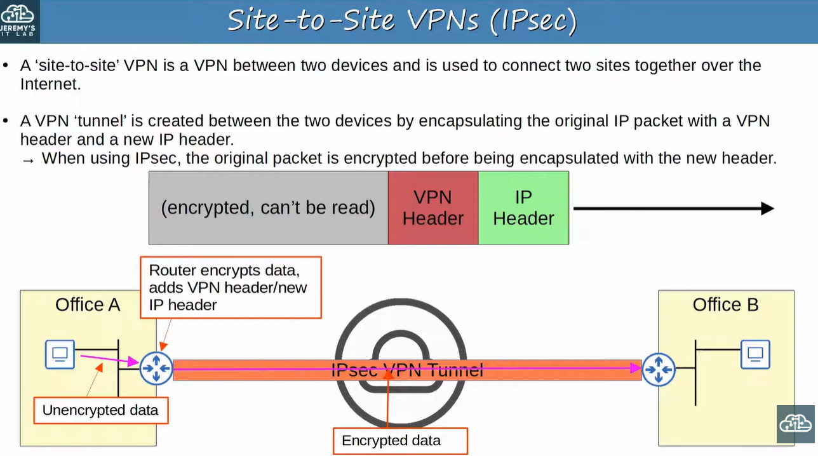
Site-to-site IPsec VPN – encapsulation and encryption

📷 Image / Diagram
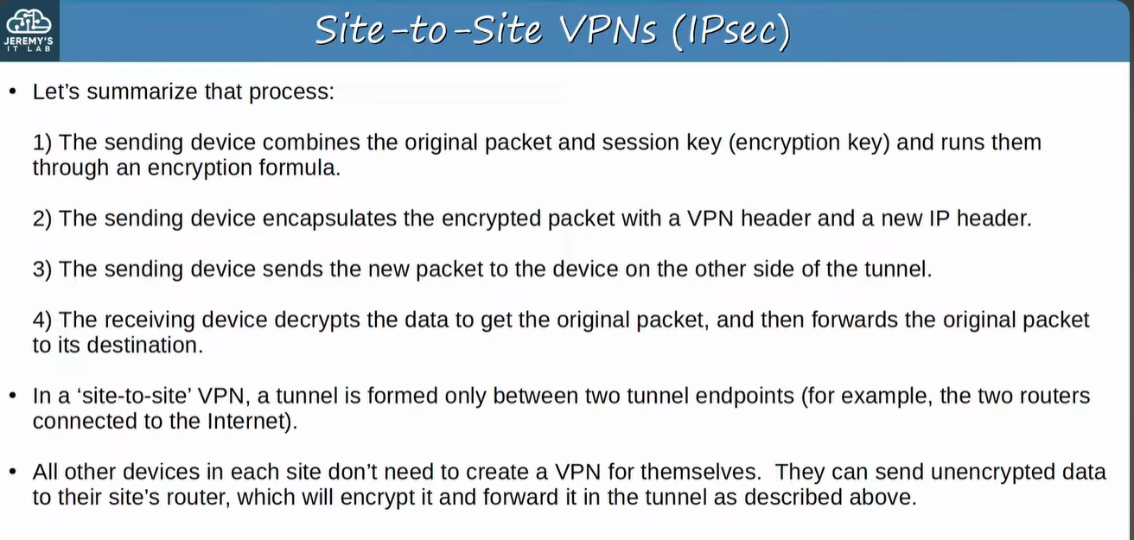
Summary of the IPsec site-to-site VPN process

Topic 16: Limitations of Standard IPsec

1. Concept
Standard IPsec has two main limitations, each with a solution.
Limitation | Why it is a problem | Solution
1) Only unicast (no broadcast/multicast) | Routing protocols like OSPF use multicast, so they cannot run over the tunnel | GRE over IPsec
2) Full mesh of tunnels is labor-intensive | Many sites = many tunnels to configure manually | Cisco DMVPN

📷 Image / Diagram
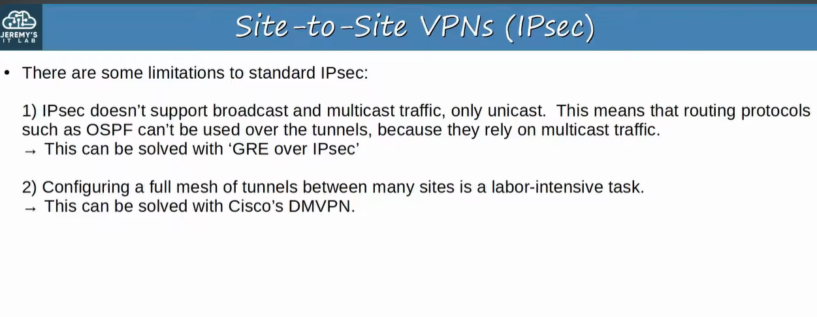
Limitations of standard IPsec

Topic 17: GRE over IPsec

1. Concept
GRE (Generic Routing Encapsulation) creates tunnels like IPsec but does NOT encrypt, so it is not secure on its own. Its advantage is that it can carry many Layer 3 protocols plus broadcast and multicast. GRE over IPsec combines GRE flexibility with IPsec security.

Key Points
- Original packet → encapsulated with GRE header + new IP header.
- The GRE packet is then encrypted and encapsulated in an IPsec VPN header + new IP header.
- Result: OSPF/multicast can work across a secure tunnel.
Feature | IPsec | GRE | GRE over IPsec
Encryption | Yes | No | Yes
Broadcast / multicast | No (unicast only) | Yes | Yes
Other L3 protocols | Limited | Yes | Yes
Routing protocols (OSPF) | Cannot run over tunnel | Can | Can
Secure? | Yes | No | Yes

📷 Image / Diagram
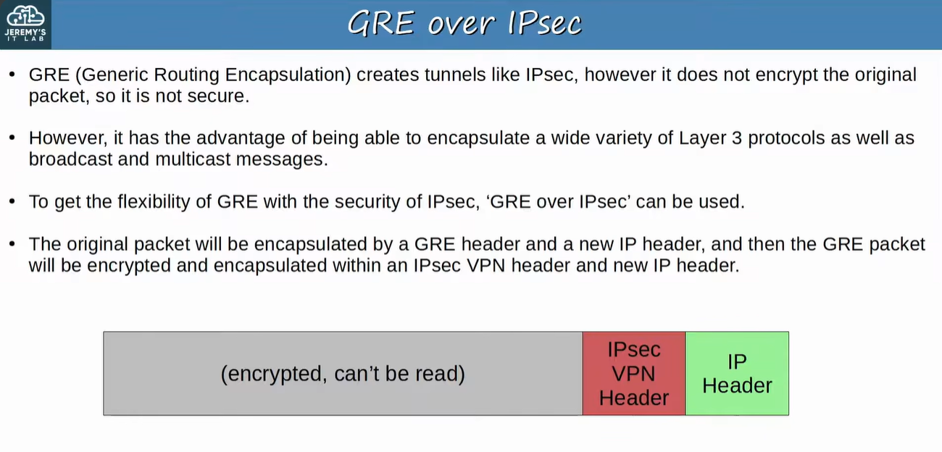
GRE over IPsec – packet encapsulation

Topic 18: Remote-Access VPNs (TLS)

1. Concept
A remote-access VPN lets end devices (PCs, mobiles) securely access the company's internal resources over the Internet. It typically uses TLS (Transport Layer Security).

Key Points
- TLS also secures HTTPS. TLS was formerly SSL (Secure Sockets Layer), developed by Netscape, renamed TLS when standardized by the IETF.
- VPN client software (e.g., Cisco AnyConnect) is installed on the end device.
- The device forms a secure tunnel to a company router/firewall acting as a TLS server.
- User accesses internal resources without being directly connected to the company network.

Example
Employee laptop at home (AnyConnect) → Internet → Company firewall (TLS server) → Internal Switch → Internal Server.
Feature | Site-to-Site VPN | Remote-Access VPN
Connects | Two sites (point-to-point) | Individual end devices to company
Protocol | IPsec | TLS
Who encrypts | Routers at each site | Client software on the device
Client software | Not needed on hosts | Required (e.g., AnyConnect)

📷 Image / Diagram
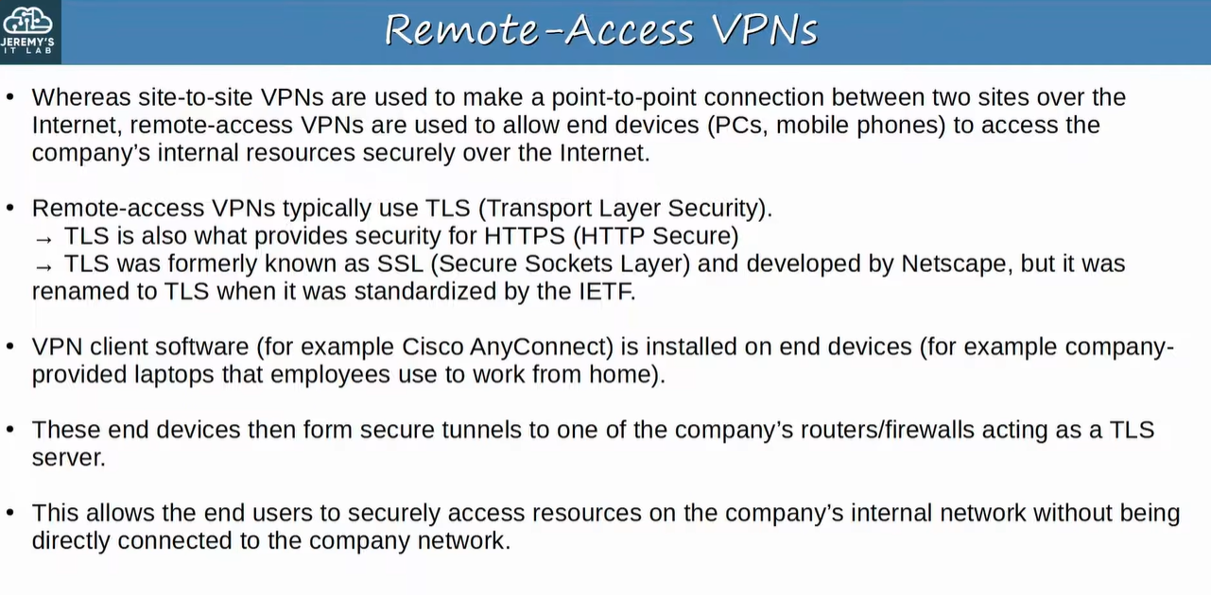
Remote-access VPN using TLS

Master Comparison: WAN Technologies
Technology | Medium / Type | Shared? | Security | Key Points
Leased Line | Dedicated serial (PPP/HDLC) | No (dedicated) | Inherently separated | Costly, slow install, slower speeds
Ethernet WAN | Ethernet over fiber | Provider network | Provider separation | Faster, cheaper, growing popularity
MPLS VPN | Provider label-switched network | Yes | Labels separate customers | CE/PE/P; L2 or L3 VPN; many access types
Internet VPN | Internet + IPsec tunnels | Yes (Internet) | Encryption needed | Cheap, quick; IPsec/GRE/DMVPN

Quick Revision
- WAN = connects geographically separate LANs.
- Leased line = dedicated, serial, PPP/HDLC, hub-and-spoke. T1 = 1.544 Mbps, E1 = 2.048 Mbps.
- Ethernet WAN (fiber) replacing leased lines: cheaper and faster.
- MPLS = labels used inside SP (not destination IP). CE (customer), PE (provider edge, adds label), P (core).
- L3 MPLS VPN: CE–PE peer (OSPF). L2 MPLS VPN: SP is transparent, CE–CE peer directly, same subnet.
- DSL = phone line + DSL modem. Cable = CATV line + cable modem.
- Single homed (1 link/1 ISP), Dual homed (2/1), Multihomed (1 each/2 ISPs), Dual multihomed (2 each/2 ISPs).
- Site-to-site VPN = IPsec (router encrypts, tunnel between 2 devices). Remote-access VPN = TLS (client software).
- IPsec = unicast only → use GRE over IPsec for OSPF/multicast. Full mesh pain → DMVPN.
- GRE = no encryption but supports multicast/broadcast/many L3 protocols.

Revision Comments & Doubts
- Why is Layer 2 MPLS "transparent"? The SP just carries frames between the two CEs, like a giant switch, so the CEs behave as if directly connected.
- Do CE routers use MPLS? No. Only PE and P routers use MPLS. The CE only sees normal IP/Ethernet.
- Is MPLS secure? Customers are separated by labels (not encryption). The slide groups it with private WAN services.
- Why can't OSPF run over plain IPsec? OSPF uses multicast and IPsec supports only unicast. Fix = GRE over IPsec.
- IPsec packet order: the slide shows the encrypted original packet followed by the VPN header and IP header. Know it as new IP header + VPN header + encrypted original packet.
- No Cisco commands appear in these slides, so none are included. IPsec/GRE/DMVPN configurations come in later topics.

Exam Points
Most likely exam questions
1. Define WAN and name the types: leased line, Ethernet WAN, MPLS VPN, Internet VPN.
2. Identify CE, PE, P routers and say who adds the label (PE).
3. L2 vs L3 MPLS VPN: who forms the OSPF peering?
4. Name the redundancy type from a diagram (single/dual/multi/dual-multihomed).
5. Why does IPsec fail with OSPF? What fixes it? (GRE over IPsec).
6. Which VPN uses IPsec (site-to-site) and which uses TLS (remote-access)?
7. T1 vs E1 speeds and channels (1.544 Mbps/24, 2.048 Mbps/32).
8. Medium used by DSL (phone line) vs Cable (CATV).

